Practical - 7
Practical Title: PHP Form Processing with Server-Side Validation and CSV/JSON File Storage
Process submitted registration/contact form data using PHP. Validate and
sanitize inputs on the server side and store records in CSV or JSON file
format. Display success/error messages.

Theory
1. Is the form submitted using POST?
Yes, the form element explicitly specifies method="POST" and submits data to itself via action="".
2. Are inputs validated and sanitized server side?
No, the PHP backend only uses the null coalescing operator (??) to capture values, but does not perform server-side validation or sanitization (such as trim(), htmlspecialchars(), or regex checks).
3. Is file writing handled safely?
No, file writing relies on basic fopen(), fwrite(), and fputcsv/string concatenation without file locking (flock()) or sanitizing commas/newlines, which can lead to CSV injection or corrupted files.
4. Are success and error responses displayed clearly?
Partially; a success state is shown via a JavaScript alert() box, but there are no backend error handling or error message displays if file opening/writing fails.

Output
- Configured an HTML registration form with method="POST" to securely send form inputs to the PHP backend processing script.
- Extracted form fields from $_POST and formatted selected values into a structured CSV string layout.
- Implemented automatic CSV creation with standard header rows and appended incoming registration details directly to data.csv on submission.

To View Code: https://github.com/shreyajodhani/studenthub.git

Evidence of Work (Screenshots)
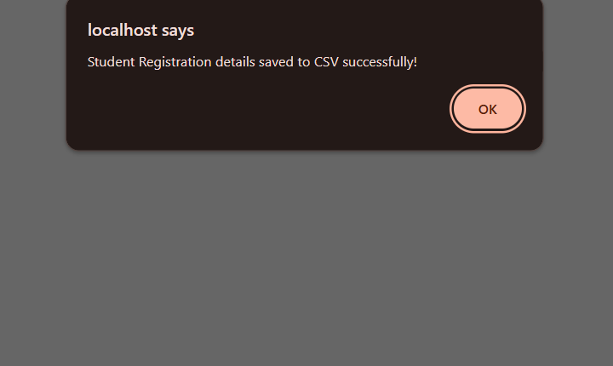
Description:
Confirm dialog after registration is successful

Description: csv file data saved from register page.

GitHub Repository Link: https://github.com/shreyajodhani/studenthub.git

Challenges Faced:

Saving all data in csv file

Learning Outcomes:
Learnt to save data from user in file
Faculty Remarks: (Keep this blank for faculty)

